Digital Arts & Technology Academy (DATA) Agenda

**Regular Governing Council Meeting**

**May 23, 2024 – 11:00 a.m.**

1011 Lamberton Place, NE ◇ Albuquerque, NM 87107

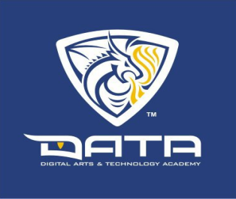

* + 1. **CALL TO ORDER**
  1. Roll Call: Jennifer McDonald, Omar Durant, Deborah Martinez, Tara Groneman
  2. Adoption of Agenda
  + Declaration of Conflicts
  + Materials Read Prior to Meeting
  1. Approval of Minutes – April 23, 2024, Regular Meeting
     1. **PUBLIC FORUM**
     2. **ACTION / DISCUSSION ITEMS**

1. Division Head Report Jeanette Perez / Adam Dodge
   * Spring Site Visit / End of Year

B. Director Report Lisa Myhre

* + Turn in PSCOC & DATA Conflict of Interest Forms
  + Public Meeting Notice Resolution

C. Financial Report Mike Vigil II / Jesse Gutierrez

* + Financial Summary
  + Budget Adjustment Requests (BAR’s),

Requests for Reimbursement (RFR’s),

& Disbursements

* + 1. **NEW BUSINESS**
    2. **EXECUTIVE SESSION**

1. To discuss the following, as permitted by the Open Meetings Act: limited personnel matters regarding the Director’s evaluation details. This is a standard, annual event. [section 10-15-1(H)(2)].
   * 1. **NEXT MEETING DATE**

A. Discussion on whether a June meeting is needed

* + 1. **ADJOURNMENT**